PRESENTING CLINICAL SIGNS
History: Heart disease – on Vetmedin, enalapril, and furosemide. Evaluation for neoplasia.
Physical Examination: Edema right hind.
Urinalysis: N/A.
CBC: N/A.
Serum Biochemistry: N/A.
Radiographic Findings: Cardiomegaly.

ULTRASONOGRAPHIC EXAMINATION OF THE ABDOMEN
Urinary System
Full urinary bladder with a normal thickness and echogenic appearance of the wall. Small amount of floating hyperechogenic sediment. No uroliths evident.
Normal trigone area, proximal urethra, and iliac blood vessels.
Normal iliac lymph nodes. Ureters not visualized.
Normal renal size (left 3.2 cm, right 3.3 cm) with increased echogenic appearance, loss of cortico-medullary differentiation, and irregular capsule. Bilateral pyelectasia – left 0.4 cm, right 0.6 cm
Reproductive System
Prostamegaly (1.1 x 1.8 cm) with a diffuse increased echogenic appearance, regular capsule, and normal appearance of the peri-prostatic tissue.
Adrenal Glands
Normal shape, echogenic appearance, position, and size. Left 1.2 x 0.46/0.4 cm, right 1.55 x 0.6/0.57 cm.
Spleen
Normal size (0.7 cm) and echogenic appearance. Irregular capsule, smooth homogenous parenchyma, regular and normal vasculature. No evidence of inflammatory, neoplastic, infarction, or infiltrative changes noted.
Liver
Normal size, echogenic appearance, portal markings, and regular curvilinear capsule. No nodules or masses evident. Small gall bladder containing normal anechoic bile. Thickened and hyperechogenic appearance of the gall bladder wall. Normal bile duct.
Gastrointestinal
Normal appearance of the duodenum, small intestine, ileo-cecal junction, and colon with no loss of layering, normal wall thickness and peristalsis, and no distension of the lumen. Fluid filled stomach with a thickened wall but with no loss of layering.

Pancreas
Normal size and echogenic appearance. Normal echogenic appearance of the mesentery and fat surrounding the pancreas.
Free Abdomen
No mesenteric lymphadenomegaly.
Large amount of acellular ascites.
Dilated caudal vena cava and hepatic veins.

ULTRASONOGRAPHIC FINDINGS
Primary findings:
- Renal disease.
- Gastropathy.
- Ascites.
- Dilated veins.
Secondary findings:
- Previous cholecystitis.
- Benign prostatic hyperplasia.

INTERPRETATION OF THE FINDINGS & FURTHER RECOMMENDATIONS
The appearance of the kidneys is consistent with chronic kidney disease.
Etiologies for the gastropathy would be edema, chronic gastritis, Helicobacter gastritis, inflammatory bowel disease, and ulcerative disease.
The ascites and dilated veins can be ascribed to right-sided heart failure.
Further assessment that could be considered would be urinalysis and renal function assay (urea, creatinine, SDMA).

In addition to the current therapy, spironolactone should be considered,

IMAGES

Stomach

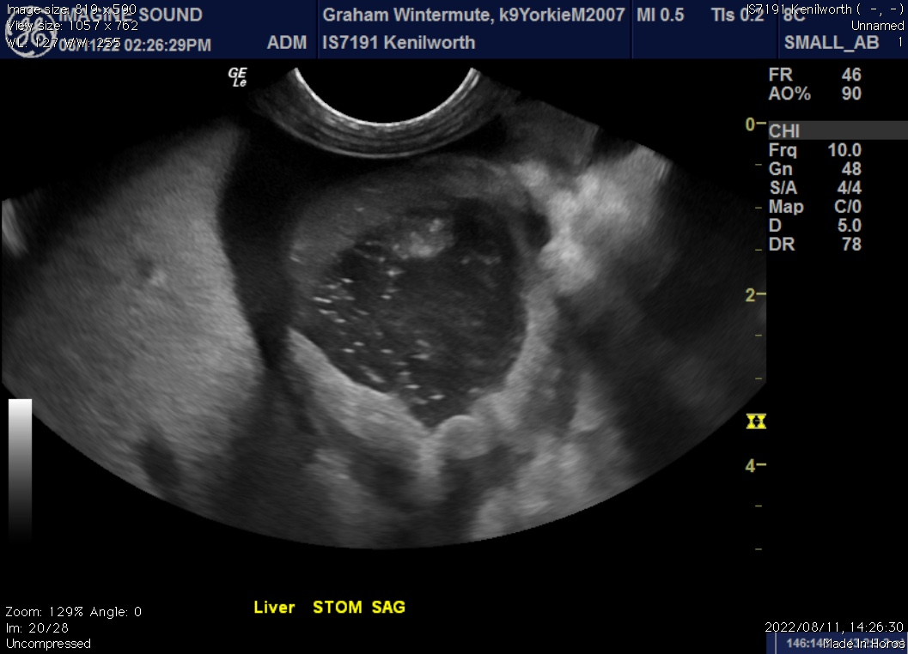

Left kidney

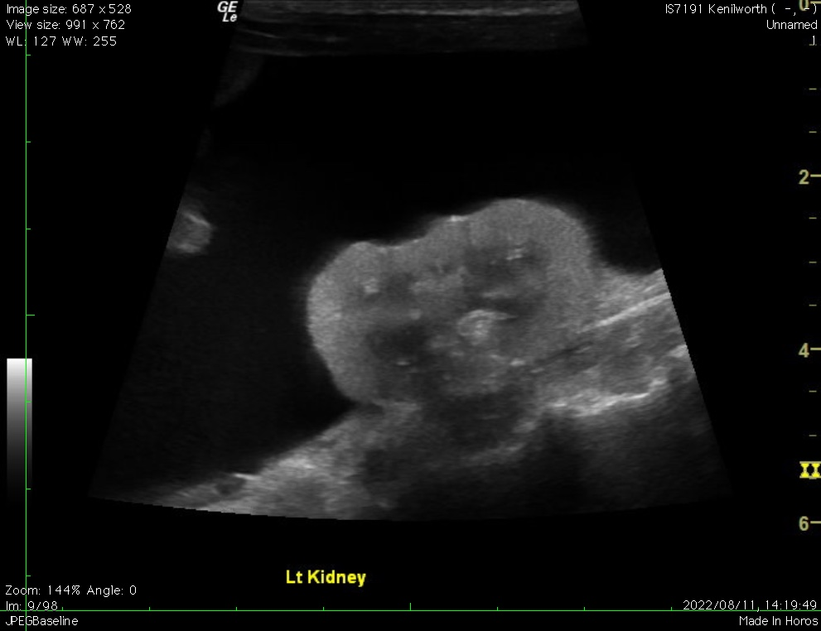

Gall bladder

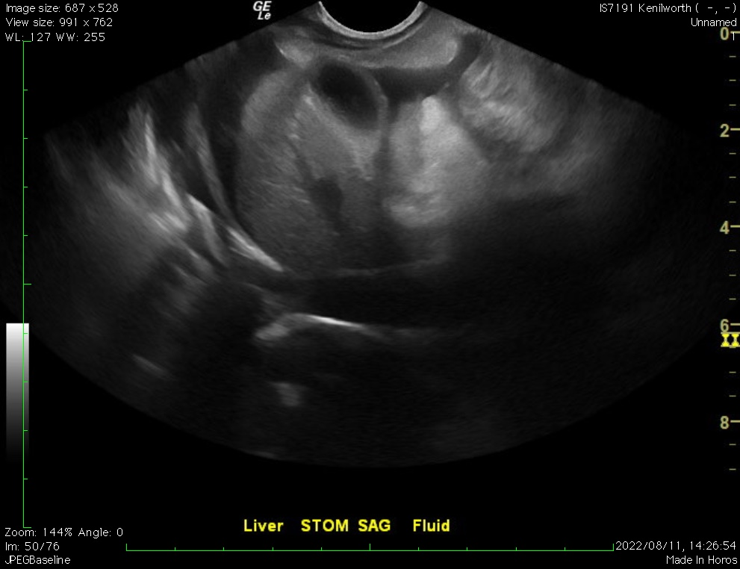

Liver/blood vessels

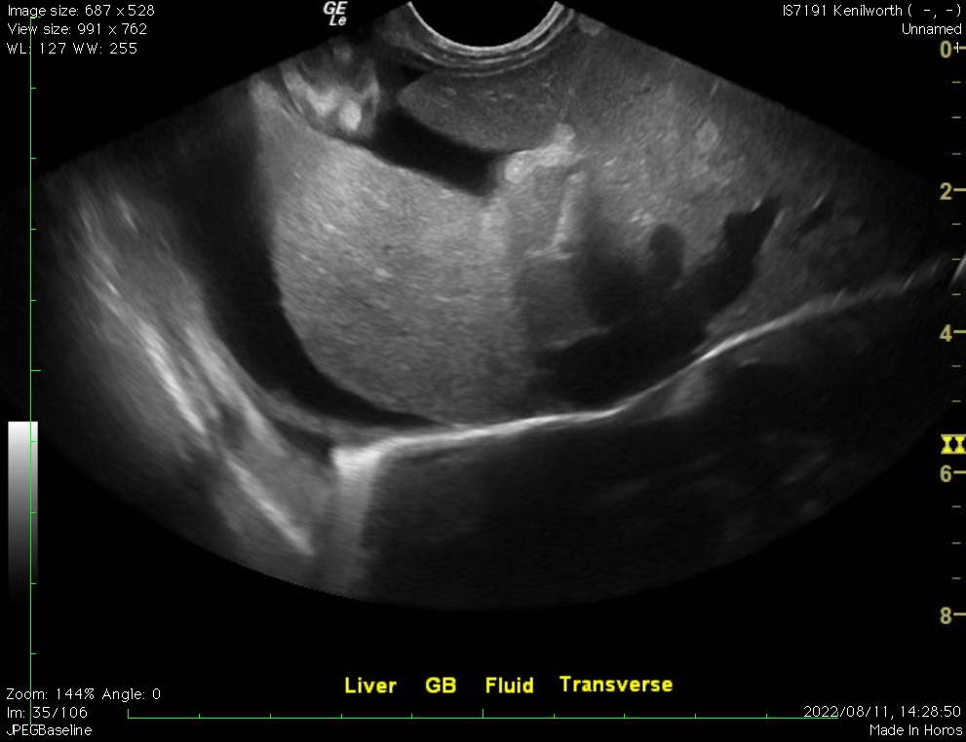

The information and recommendations provided are based on the images presented by the referring veterinarian. No evaluation can be communicated regarding pathology that was not visible in the image/video clips provided.

Thank you for this referral. If the clinical or image interpretation does not parallel your findings or if I can be of any further assistance, please contact me.

Remo Lobetti, BVSc, MMedVet (Med), PhD, Dipl. ECVIM (Internal Medicine)
rlobetti@mweb.co.za

